 

**GHARDA FOUNDATION**

**GHARDA INSTITUTE OF TECHNOLOGY, LAVEL**

Department of Computer Engineering

# Evaluation Sheet

Class: TE-Computer Engineering Sem: V

Subject: **Computer Networks**

Experiment No: 8

Title of Experiment: [Study](https://drive.google.com/file/d/1uQMn8WeCWn0VEWeEtmYb4FUtzgDM8wVN/view?usp=sharing) of Remote Login using TELNET

Name of Student: Harvande Sanket Chandrashekhar Roll No: 19

|  |  |  |  |
| --- | --- | --- | --- |
| Sr. No. | Evaluation Criteria | Max Marks | Marks Obtained |
| 1 | Practical Performance | 8 |  |
| 2 | Oral | 5 |  |
| 3 | Timely Submission | 2 |  |
|  | Total | 15 |  |

Signature of Subject Teacher

(Mr. S. S. Tathare)

**Aim**: To study [the](https://drive.google.com/file/d/1uQMn8WeCWn0VEWeEtmYb4FUtzgDM8wVN/view?usp=sharing) implementation of TELNET remote login using CISCO packet tracer.

**Apparatus**: Packet Tracer software **Procedure**:

1. Configure a network using at-least two switches, two routers and 4 PC.
2. Configure IP addresses of all PCs and the router interfaces using proper rules of classless addressing.
3. Ensure that all the connections turn green which indicate the connections as UP.
4. Check for the connectivity using ICMP ping command, the connectivity fails.
5. Configure dynamic routing on both the routers using distance vector routing protocol, RIP.
6. Check for the connectivity using ICMP ping command, the connectivity succeeds. 7. Configure TELNET on one router using the commands of telnet configuration ensuring one access to the router in remote logging method.
7. Using one of the PC on remote network, take the remote login to the router using telnet command and make the changes on the router.

Screenshots :

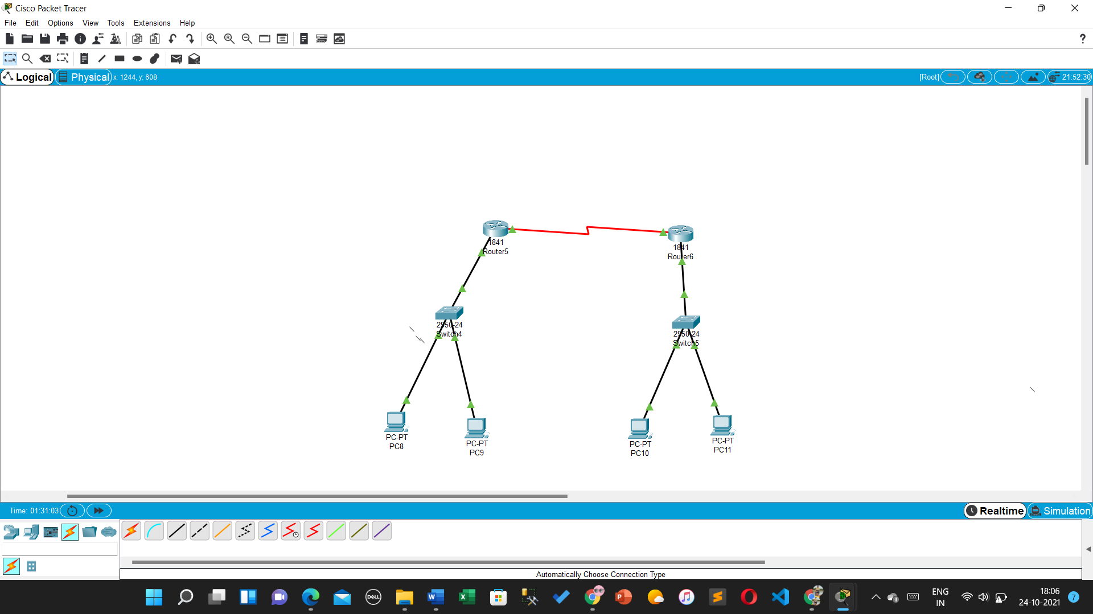

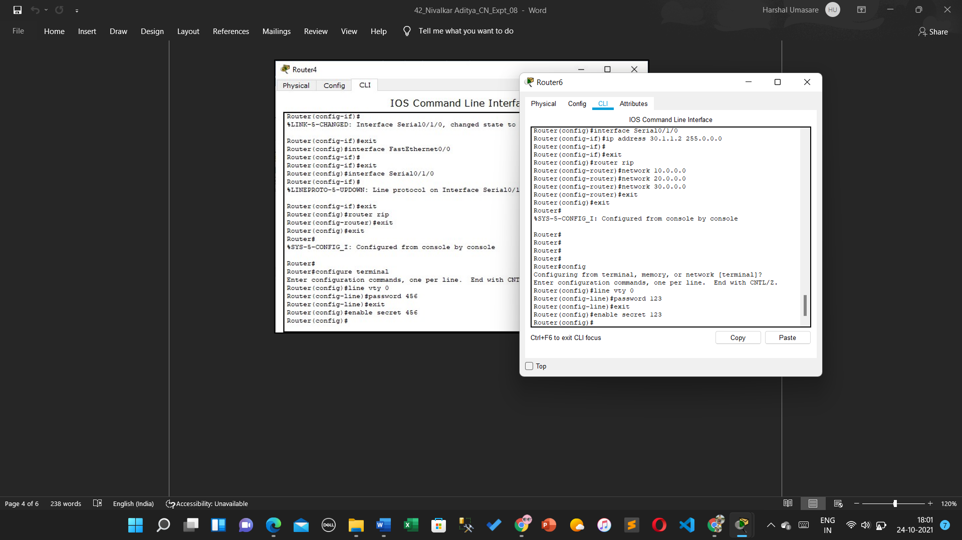

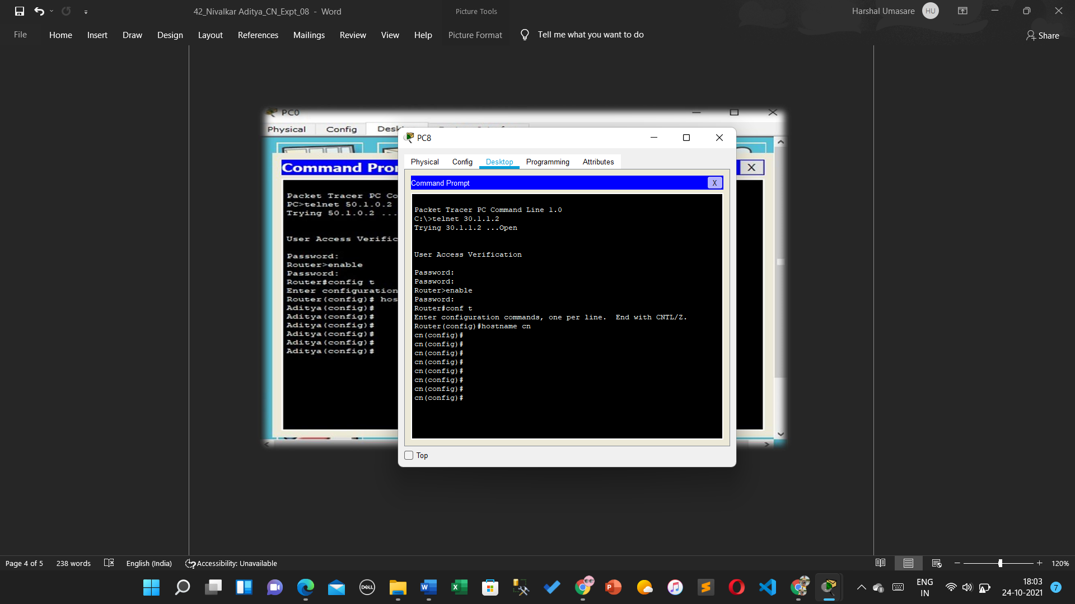

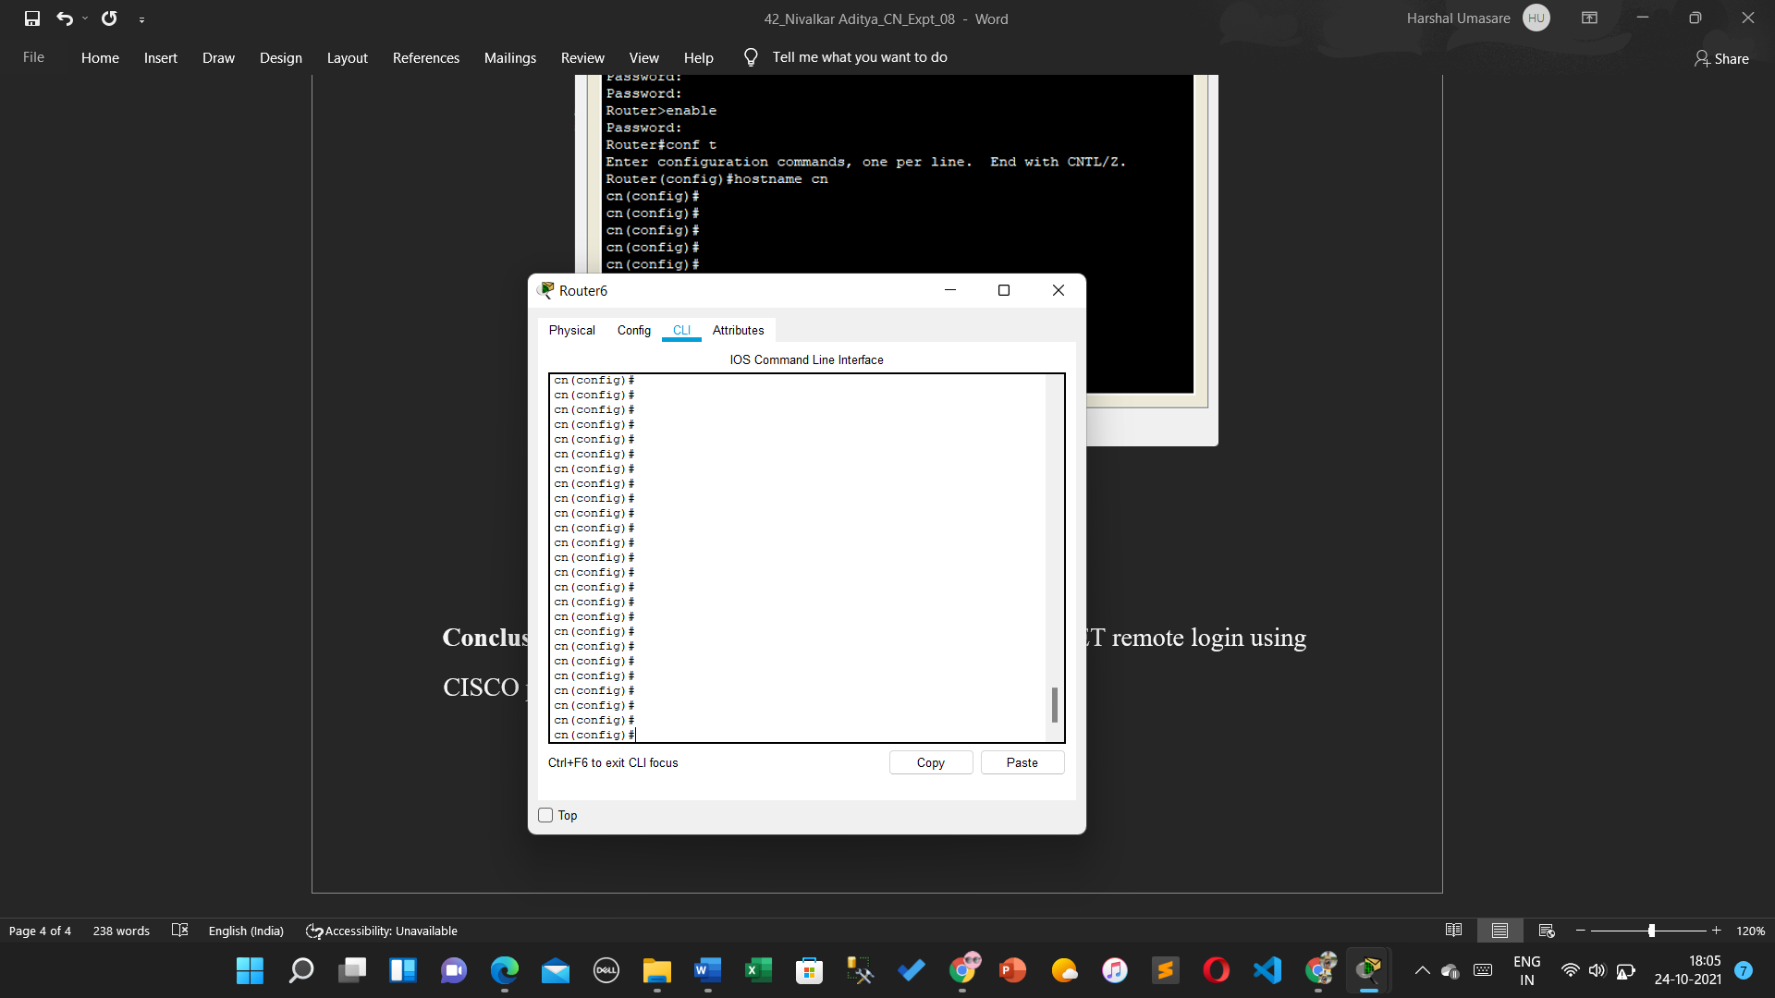

**Conclusion**: Thus, the study of [the](https://drive.google.com/file/d/1uQMn8WeCWn0VEWeEtmYb4FUtzgDM8wVN/view?usp=sharing) implementation of TELNET remote login using CISCO packet tracer is done.